Suffix trie
Introduction
In some cases one has to answer many queries where can some string be found in a text. For example, if you have book which is stored in plain text format on your computer, you may want to find out the places where “Bob” is mentioned, then “Alice”, etc. All of the previous methods implemented (Rabin karp, z algo, kmp, etc) would not be effective for this problem since they would have to be run for each query.
In this sense, it is wiser to do some preprocessing on the text and answer the queries effectively. If the queries are not so many, then the previous approaches are good. However, in Bioinformatics for example one would be interested to search for a given genome sequence multiple times or generally use this structure to compute something else.

Description
A trie is basically a tree which stores data on both the nodes and edges. Generally, if a node is a child of another node then those two nodes take part in some kind of sequence (like a string for example). The suffix trie stores all suffixes of a given string in this tree structure.
Let us say that the word is “banana”.
Then, all suffices are:
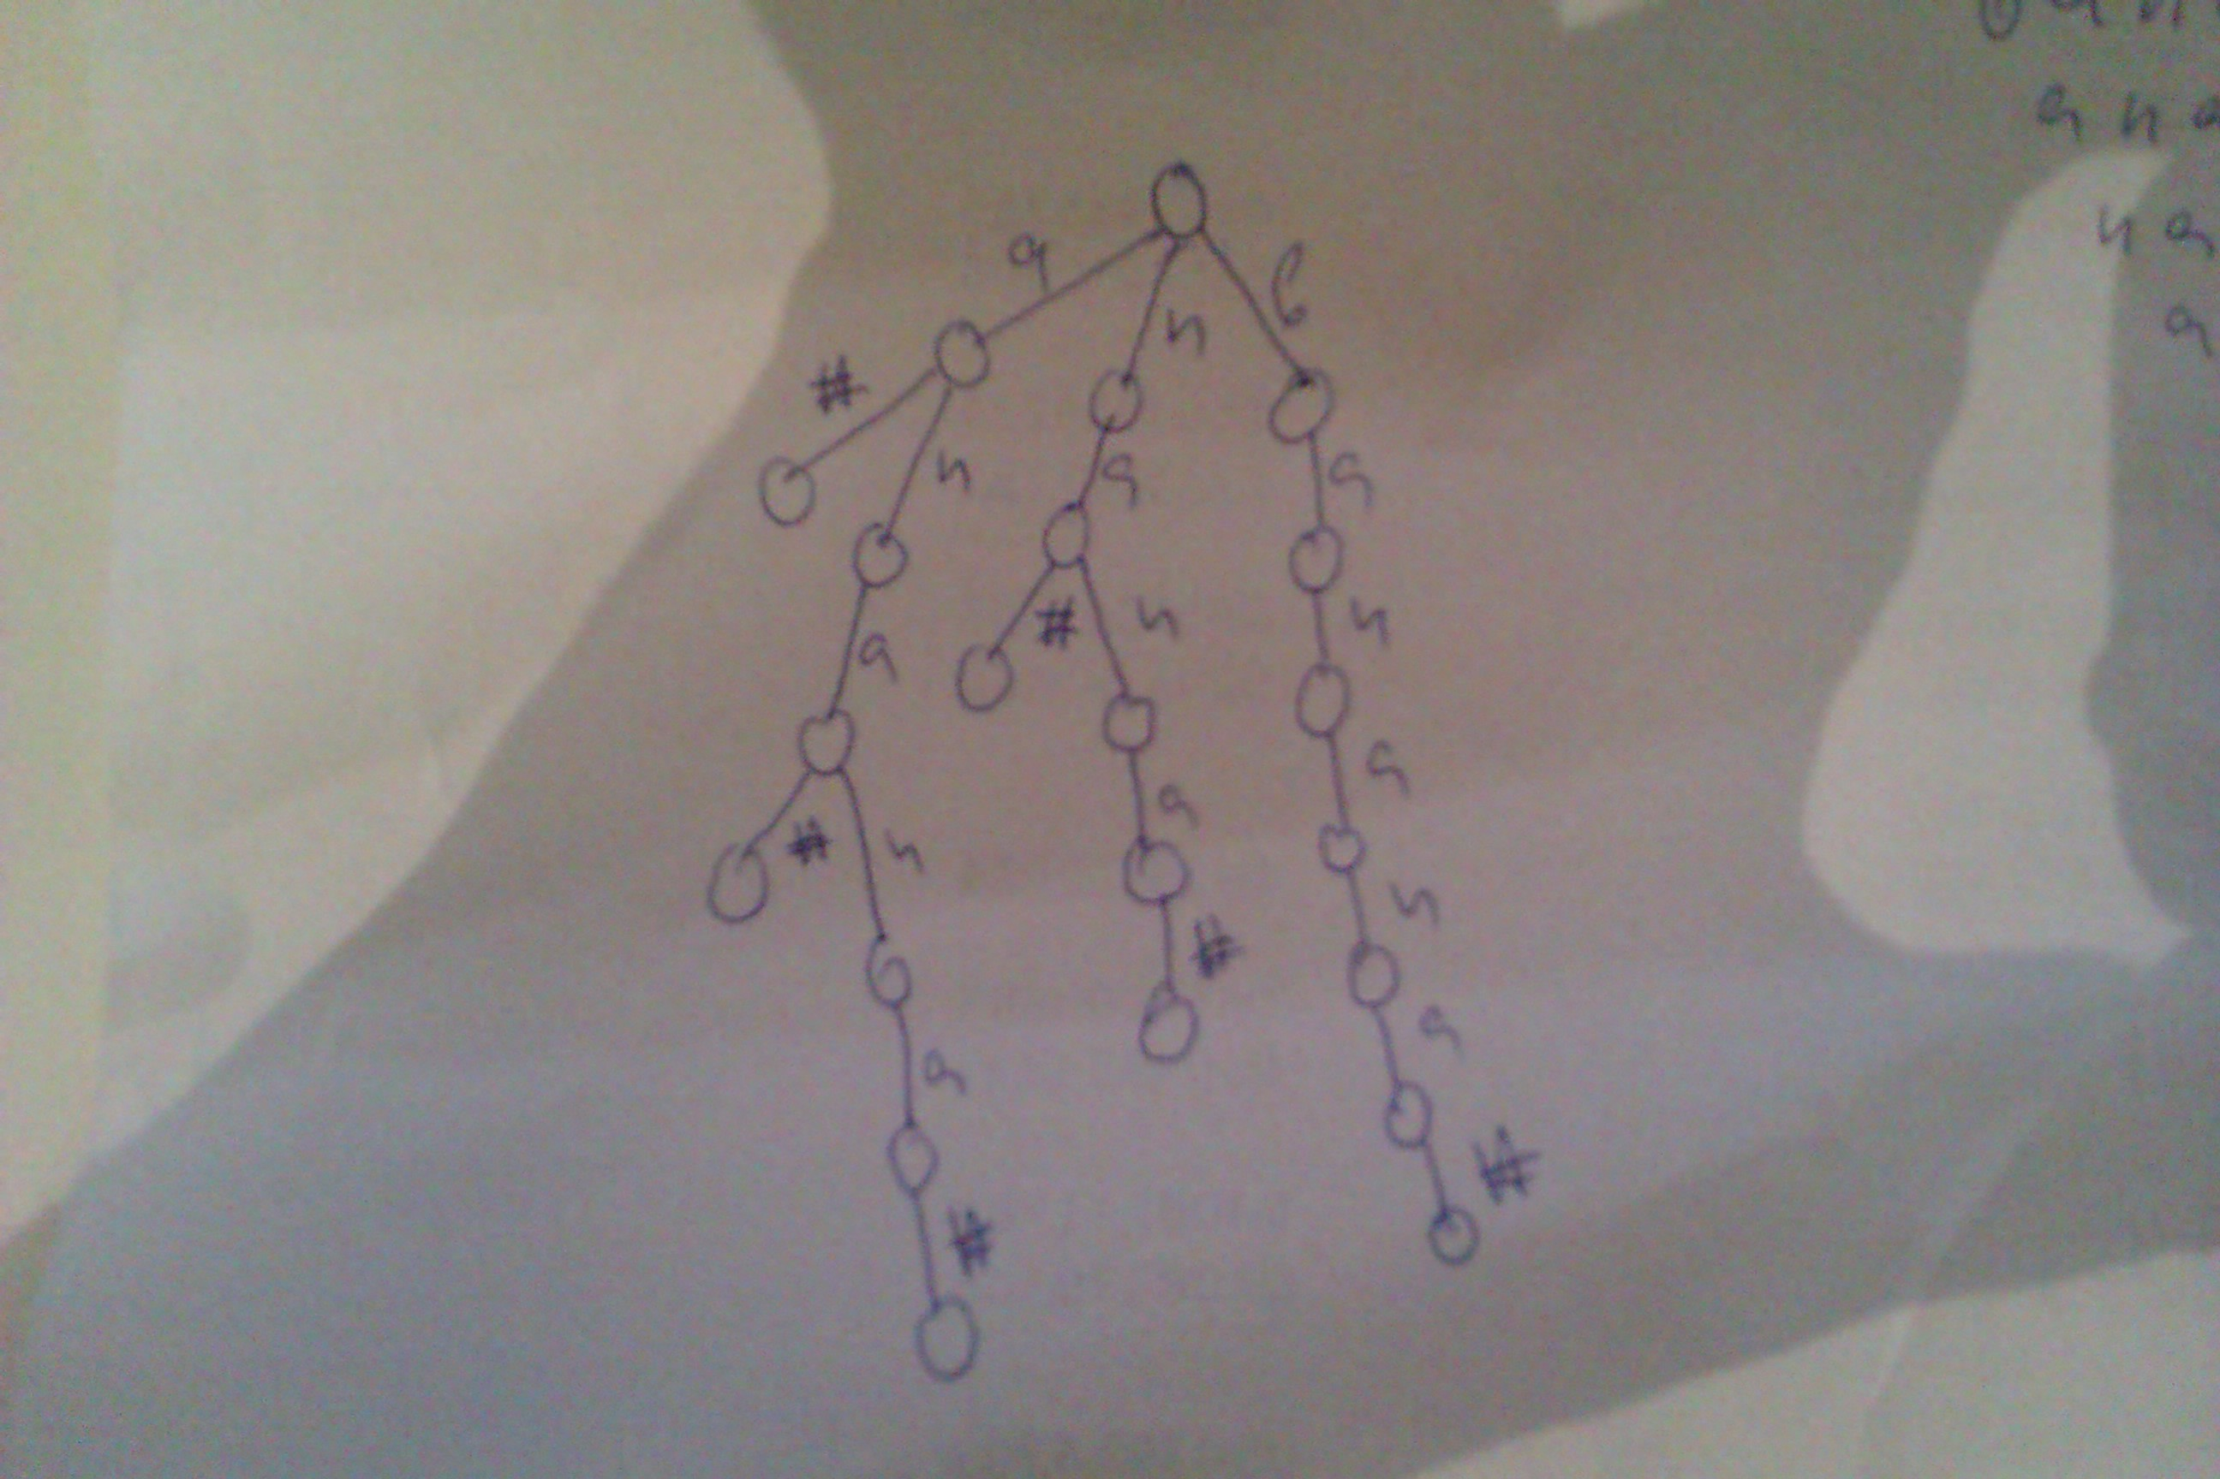
banana
anana
nana
ana
na
a

Where # is some character which does not occur in the string. It is added so that some suffix is not also a prefix of the string.

Generating the suffix trie
One can do it by starting at the end and going back to the beginning in reverse order. Building the trie takes O(n^2) time which means that we cannot use this structure for very big texts (more than 1000 characters would cause problems).

Searching in the suffix trie
It is just like traversing a tree. You just find the right edge. If you store the edges in a map or in an array (if the alphabet size is small → works good for genome sequences for examle), then you can find the right edge in O(1) time. Thus, it takes O(M) time to search for the occurrence of the string in the text where M is the length of the string (needle).

Since, a substring in the preprocessed text may not be a suffix, then it is a good idea to store information about which lead to the creation of the edge (which index it started from).

Conclusion
Suffix trie is a very basic structure for string searching. However, it can be improved by compressing the paths and doing some other tricks. Next two chapters would cover: Suffix Tree and Ukkonen suffix tree

